Business & Investing

The Intelligent Investor REV Ed.

[Benjamin Graham](https://bookshop.org/contributors/benjamin-graham) (Author)

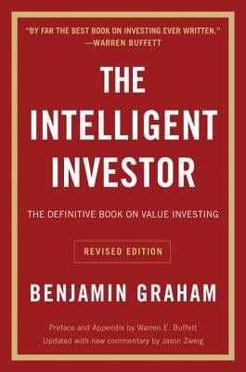

Description

"By far the best book on investing ever written." -- Warren Buffett

The greatest investment advisor of the twentieth century, Benjamin Graham taught and inspired people worldwide. Graham's philosophy of "value investing"--which shields investors from substantial error and teaches them to develop long-term strategies--has made The Intelligent Investor the stock market bible ever since its original publication in 1949.

Over the years, market developments have proven the wisdom of Graham's strategies. While preserving the integrity of Graham's original text, this revised edition includes updated commentary by noted financial journalist Jason Zweig, whose perspective incorporates the realities of today's market, draws parallels between Graham's examples and today's financial headlines, and gives readers a more thorough understanding of how to apply Graham's principles.

Vital and indispensable, The Intelligent Investor is the most important book you will ever read on how to reach your financial goals.

### Product Details

Price

~~$24.99~~  **$22.99**

Publisher

Harper Business

Publish Date

February 21, 2006

Pages

640

Dimensions

5.3 X 8.0 X 1.6 inches | 1.05 pounds

Language

English

Type

Paperback

About the Author

Benjamin Graham (1894-1976), the father of value investing, has been an inspiration for many of today's most successful businesspeople. He is also the author of Securities Analysis and The Interpretation of Financial Statements.

Security Analysis: Sixth Edition, Foreword by Warren Buffett (Revised)

[David Dodd](https://bookshop.org/contributors/david-dodd-3afce22e-9cdf-4a94-a454-d9c1b202f6a3) (Author)  [Benjamin Graham](https://bookshop.org/contributors/benjamin-graham) (Author)

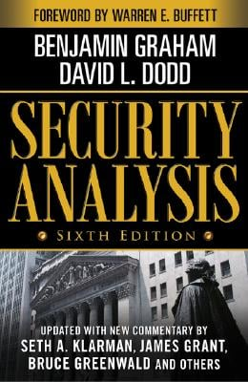

Description

"A road map for investing that I have now been following for 57 years."  
--From the Foreword by Warren E. Buffett

First published in 1934, Security Analysis is one of the most influential financial books ever written. Selling more than one million copies through five editions, it has provided generations of investors with the timeless value investing philosophy and techniques of Benjamin Graham and David L. Dodd.

As relevant today as when they first appeared nearly 75 years ago, the teachings of Benjamin Graham, "the father of value investing," have withstood the test of time across a wide diversity of market conditions, countries, and asset classes.

This new sixth edition, based on the classic 1940 version, is enhanced with 200 additional pages of commentary from some of today's leading Wall Street money managers. These masters of value investing explain why the principles and techniques of Graham and Dodd are still highly relevant even in today's vastly different markets. The contributor list includes:

Seth A. Klarman, president of The Baupost Group, L.L.C. and author of Margin of Safety

James Grant, founder of Grant's Interest Rate Observer, general partner of Nippon Partners

Jeffrey M. Laderman, twenty-five year veteran of BusinessWeek

Roger Lowenstein, author of Buffett: The Making of an American Capitalist and When America Aged and Outside Director, Sequoia Fund

Howard S. Marks, CFA, Chairman and Co-Founder, Oaktree Capital Management L.P.

J. Ezra Merkin, Managing Partner, Gabriel Capital Group .

Bruce Berkowitz, Founder, Fairholme Capital Management.

Glenn H. Greenberg, Co-Founder and Managing Director, Chieftain Capital Management

Bruce Greenwald, Robert Heilbrunn Professor of Finance and Asset Management, Columbia Business School

David Abrams, Managing Member, Abrams Capital

Featuring a foreword by Warren E. Buffett (in which he reveals that he has read the 1940 masterwork "at least four times"), this new edition of *Security Analysis* will reacquaint you with the foundations of value investing--more relevant than ever in the tumultuous 21st century markets.

### Product Details

Price

~~$82.00~~  **$75.44**

Publisher

McGraw-Hill Education

Publish Date

September 01, 2008

Pages

700

Dimensions

6.5 X 2.44 X 9.18 inches | 2.83 pounds

Language

English

Type

Hardcover

About the Author

Benjamin Graham is considered to be the founder of value investing and taught at Columbia University's Graduate School of Business.

David L. Dodd was a colleague of Graham's at Columbia University, where he was an assistant professor of finance.

Common Stocks and Uncommon Profits and Other Writings

[Philip A Fisher](https://bookshop.org/contributors/philip-a-fisher) (Author)  [Kenneth L. Fisher](https://bookshop.org/contributors/kenneth-l-fisher) (Introduction by)

[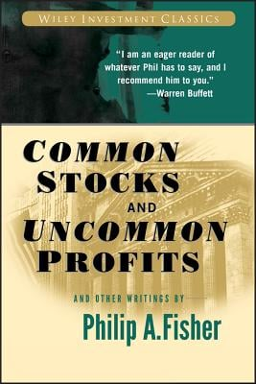](https://images-production.bookshop.org/spree/images/attachments/6560988/original/9780471445500.jpg?1588664476)

Description

Philip Fisher gilt als einer der Pioniere der modernen Investmenttheorie und zählt zu den einflussreichsten Investoren aller Zeiten.  
  
Seine Investmentphilosophien, die er vor fast 40 vorgestellt hat, werden nicht nur von modernen Finanzexperten und Investoren - inklusive Warren Buffett - studiert und angewendet, sondern gelten für viele als das Evangelium schlechthin.  
  
Common Stocks and Uncommon Profits and Other Writings ist die aktualisierte Broschurausgabe der 1958 erschienenen Originalausgabe.  
  
Diese Neuauflage stellt Fishers Ideen einer neuen Generation von Investoren vor.  
  
Sie enthält alle Investmentweisheiten der Originalausgabe sowie ein erweitertes Vorwort und eine Einleitung von Philip Fishers Sohn Ken - selbst ein angesehener Investment-Guru. Ken Fisher beschreibt hier, wie dieses Buch sein Privat- und Berufsleben beeinflusst hat und geht ausführlich auf die Investmentleidenschaft seines Vaters ein.  
  
Common Stocks and Uncommon Profits and Other Writings - eine unverzichtbare Lektüre für Finanzinteressierte, Anleger und Finanzexperten gleicherma en.  
  
Die Neuauflage erscheint in neuem Design als Band der Reihe 'Wiley's Investment Classics Series'.

### Product Details

Price

~~$24.95~~  **$22.95**

Publisher

Wiley

Publish Date

August 29, 2003

Pages

292

Dimensions

6.04 X 0.85 X 9.0 inches | 0.86 pounds

Language

English

Type

Paperback

About the Author

PHILIP A. FISHER began his career as a securities analyst in 1928, and founded Fisher & Company, an investment counseling business, in 1931. He is known as one of the pioneers of modern investment theory.

Stress Test: Reflections on Financial Crises

[Timothy F. Geithner](https://bookshop.org/contributors/timothy-f-geithner) (Author)

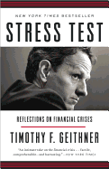

Description

New York Times Bestseller  
  
Washington Post Bestseller

Los Angeles Times Bestseller  
  
Stress Test is the story of Tim Geithner's education in financial crises.  
  
As president of the Federal Reserve Bank of New York and then as President Barack Obama's secretary of the Treasury, Timothy F. Geithner helped the United States navigate the worst financial crisis since the Great Depression, from boom to bust to rescue to recovery. In a candid, riveting, and historically illuminating memoir, he takes readers behind the scenes of the crisis, explaining the hard choices and politically unpalatable decisions he made to repair a broken financial system and prevent the collapse of the Main Street economy. This is the inside story of how a small group of policy makers--in a thick fog of uncertainty, with unimaginably high stakes--helped avoid a second depression but lost the American people doing it. Stress Test is also a valuable guide to how governments can better manage financial crises, because this one won't be the last.

Stress Test reveals a side of Secretary Geithner the public has never seen, starting with his childhood as an American abroad. He recounts his early days as a young Treasury official helping to fight the international financial crises of the 1990s, then describes what he saw, what he did, and what he missed at the New York Fed before the Wall Street boom went bust. He takes readers inside the room as the crisis began, intensified, and burned out of control, discussing the most controversial episodes of his tenures at the New York Fed and the Treasury, including the rescue of Bear Stearns; the harrowing weekend when Lehman Brothers failed; the searing crucible of the AIG rescue as well as the furor over the firm's lavish bonuses; the battles inside the Obama administration over his widely criticized but ultimately successful plan to end the crisis; and the bracing fight for the most sweeping financial reforms in more than seventy years. Secretary Geithner also describes the aftershocks of the crisis, including the administration's efforts to address high unemployment, a series of brutal political battles over deficits and debt, and the drama over Europe's repeated flirtations with the economic abyss.

Secretary Geithner is not a politician, but he has things to say about politics--the silliness, the nastiness, the toll it took on his family. But in the end, Stress Test is a hopeful story about public service. In this revealing memoir, Tim Geithner explains how America withstood the ultimate stress test of its political and financial systems.

### Product Details

Price

~~$20.00~~  **$18.40**

Publisher

Crown Publishing Group (NY)

Publish Date

May 05, 2015

Pages

592

Dimensions

5.0 X 8.0 X 1.3 inches | 0.9 pounds

Language

English

Type

Paperback

About the Author

TIMOTHY F. GEITHNER was the seventy-fifth secretary of the U.S. Department of the Treasury and previously served as president and chief executive officer of the Federal Reserve Bank of New York. He wrote this book as a distinguished fellow at the Council on Foreign Relations.

The Clash of the Cultures: Investment vs. Speculation

[John C Bogle](https://bookshop.org/contributors/john-c-bogle) (Author)  [Arthur Levitt](https://bookshop.org/contributors/arthur-levitt-bdf2f096-bb6f-4f63-a4ad-55902ddeccc9) (Foreword by)

[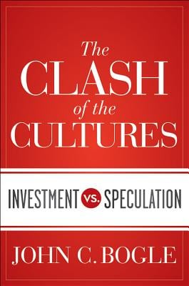](https://images-production.bookshop.org/spree/images/attachments/8596189/original/9781118122778.jpg?1588303520)

Description

Recommended Reading by Warren Buffet in his March 2013 Letter to Shareholders  
  
How speculation has come to dominate investment--a hard-hitting look from the creator of the first index fund.

Over the course of his sixty-year career in the mutual fund industry, Vanguard Group founder John C. Bogle has witnessed a massive shift in the culture of the financial sector. The prudent, value-adding culture of long-term investment has been crowded out by an aggressive, value-destroying culture of short-term speculation. Mr. Bogle has not been merely an eye-witness to these changes, but one of the financial sector's most active participants. In The Clash of the Cultures, he urges a return to the common sense principles of long-term investing.

Provocative and refreshingly candid, this book discusses Mr. Bogle's views on the changing culture in the mutual fund industry, how speculation has invaded our national retirement system, the failure of our institutional money managers to effectively participate in corporate governance, and the need for a federal standard of fiduciary duty.

Mr. Bogle recounts the history of the index mutual fund, how he created it, and how exchange-traded index funds have altered its original concept of long-term investing. He also presents a first-hand history of Wellington Fund, a real-world case study on the success of investment and the failure of speculation. The book concludes with ten simple rules that will help investors meet their financial goals. Here, he presents a common sense strategy that may not be the best strategy ever devised. But the number of strategies that are worse is infinite.

The Clash of the Cultures: Investment vs. Speculation completes the trilogy of best-selling books, beginning with Bogle on Investing: The First 50 Years (2001) and Don't Count on It! (2011)

### Product Details

Price

~~$29.95~~  **$27.55**

Publisher

Wiley

Publish Date

August 07, 2012

Pages

384

Dimensions

6.39 X 9.24 X 1.26 inches | 1.44 pounds

Language

English

Type

Hardcover

About the Author

John C. Bogle is the founder of the Vanguard Group of mutual funds and President of its Bogle Financial Markets Research Center. He created Vanguard in 1974 and served as chairman and chief executive officer until 1996 and senior chairman until 2000. In 1999, Fortune magazine named Mr. Bogle as one of the four Investment Giants of the twentieth century. In 2004, Time magazine named him one of the world's 100 most powerful and influential people, and Institutional Investor presented him with its Lifetime Achievement Award. In 2010, Forbes magazine described him as the person who has done more good for investors than any other financier of the past century. In January 2012, some of the nation's most respected financial leaders celebrated his distinguished career at the John C. Bogle Legacy Forum, held at New York's Museum of American Finance.

The Outsiders: Eight Unconventional CEOs and Their Radically Rational Blueprint for Success

[William N Thorndike](https://bookshop.org/contributors/william-n-thorndike) (Author)

[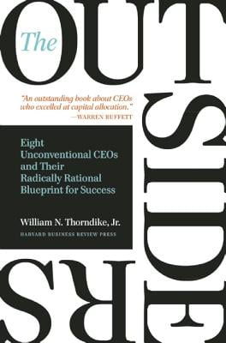](https://images-production.bookshop.org/spree/images/attachments/8057025/original/9781422162675.jpg?1588495661)

Description

"An outstanding book about CEOs who excelled at capital allocation." -- Warren Buffett

#1 on Warren Buffett's Recommended Reading List, Berkshire Hathaway Annual Shareholder Letter, 2012

Named one of "19 Books Billionaire Charlie Munger Thinks You Should Read" in Business Insider.

"A book that details the extraordinary success of CEOs who took a radically different approach to corporate management." -- Charlie Munger, Vice-Chairman of Berkshire Hathaway Corporation

"Thorndike explores the importance of thoughtful capital allocation through the stories of eight successful CEOs. A good read for any business leader but especially those willing to chart their own course." -- Michael Dell, chairman of the board of directors and chief executive officer of Dell

What makes a successful CEO? Most people call to mind a familiar definition: "a seasoned manager with deep industry expertise." Others might point to the qualities of today's so-called celebrity CEOs--charisma, virtuoso communication skills, and a confident management style. But what really matters when you run an organization? What is the hallmark of exceptional CEO performance? Quite simply, it is the returns for the shareholders of that company over the long term.

In this refreshing, counterintuitive book, author Will Thorndike brings to bear the analytical wisdom of a successful career in investing, closely evaluating the performance of companies and their leaders. You will meet eight individualistic CEOs whose firms' average returns outperformed the S&P 500 by a factor of twenty--in other words, an investment of $10,000 with each of these CEOs, on average, would have been worth over $1.5 million twenty-five years later. You may not know all their names, but you will recognize their companies: General Cinema, Ralston Purina, The Washington Post Company, Berkshire Hathaway, General Dynamics, Capital Cities Broadcasting, TCI, and Teledyne. In The Outsiders, you'll learn the traits and methods--striking for their consistency and relentless rationality--that helped these unique leaders achieve such exceptional performance.

Humble, unassuming, and often frugal, these "outsiders" shunned Wall Street and the press, and shied away from the hottest new management trends. Instead, they shared specific traits that put them and the companies they led on winning trajectories: a laser-sharp focus on per share value as opposed to earnings or sales growth; an exceptional talent for allocating capital and human resources; and the belief that cash flow, not reported earnings, determines a company's long-term value.

Drawing on years of research and experience, Thorndike tells eye-opening stories, extracting lessons and revealing a compelling alternative model for anyone interested in leading a company or investing in one--and reaping extraordinary returns.

### Product Details

Price

~~$32.00~~  **$29.44**

Publisher

Harvard Business Review Press

Publish Date

October 23, 2012

Pages

251

Dimensions

5.6 X 1.1 X 8.2 inches | 0.85 pounds

Language

English

Type

Hardcover

About the Author

William N. Thorndike is founder and a managing director of Housatonic Partners, a private equity firm. He is a graduate of Harvard College and the Stanford Graduate School of Business and has been a guest lecturer at the Harvard and Stanford business schools. He is a director of eight companies, and two not-for-profit organizations and lives in the Boston area with his wife and two children.

Jack: Straight from the Gut

[Jack Welch](https://bookshop.org/contributors/jack-welch) (Author)  [John A Byrne](https://bookshop.org/contributors/john-a-byrne-73e305ce-90ee-4fe0-8c1a-622ffb32c319) (Author)

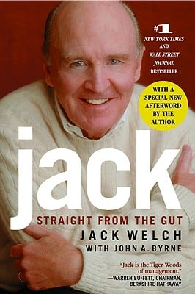

Description

The most widely respected CEO in America looks back on his brilliant career at General Electric and reveals his personal business philosophy and unique managerial style.  
Nearly 20 years ago, former General Electric CEO Reg Jones walked into Jack Welch's office and wrapped him in a bear hug. "Congratulations, Mr. Chairman," said Reg. It was a defining moment for American business. So begins the story of a self-made man and a self-described rebel who thrived in one of the most volatile and economically robust eras in U.S. history, while managing to maintain a unique leadership style. In what is the most anticipated book on business management for our time, Jack Welch surveys the landscape of his career running one of the world's largest and most successful corporations.

### Product Details

Price

~~$19.99~~  **$18.39**

Publisher

Grand Central Publishing

Publish Date

October 01, 2003

Pages

480

Dimensions

6.2 X 1.34 X 8.86 inches | 1.23 pounds

Language

English

Type

Paperback

About the Author

Jack Welch joined GE in 1960. In 1981, he became the eighth chairman and CEO. He lives in Fairfield, Connecticut.

Business Adventures: Twelve Classic Tales from the World of Wall Street

[John Brooks](https://bookshop.org/contributors/john-brooks) (Author)

[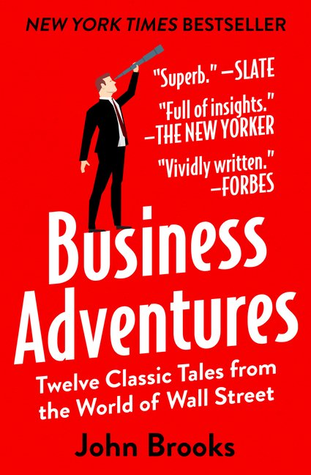](https://images-production.bookshop.org/spree/images/attachments/5639801/original/9781497644892.jpg?1620861757)

Description

"Business Adventures remains the best business book I've ever read." --Bill Gates, The Wall Street Journal  
  
What do the $350 million Ford Motor Company disaster known as the Edsel, the fast and incredible rise of Xerox, and the unbelievable scandals at General Electric and Texas Gulf Sulphur have in common? Each is an example of how an iconic company was defined by a particular moment of fame or notoriety; these notable and fascinating accounts are as relevant today to understanding the intricacies of corporate life as they were when the events happened.  
  
Stories about Wall Street are infused with drama and adventure and reveal the machinations and volatile nature of the world of finance. Longtime New Yorker contributor John Brooks's insightful reportage is so full of personality and critical detail that whether he is looking at the astounding market crash of 1962, the collapse of a well-known brokerage firm, or the bold attempt by American bankers to save the British pound, one gets the sense that history repeats itself.  
  
Five additional stories on equally fascinating subjects round out this wonderful collection that will both entertain and inform readers . . . Business Adventures is truly financial journalism at its liveliest and best.

### Product Details

Price

~~$18.99~~  **$17.47**

Publisher

Open Road Media

Publish Date

August 12, 2014

Pages

464

Dimensions

5.2 X 1.0 X 7.9 inches | 1.16 pounds

Language

English

Type

Paperback

About the Author

John Brooks (1920-1993) was an award-winning writer best known for his contributions to the New Yorker as a financial journalist. He was also the author of ten nonfiction books on business and finance, a number of which were critically acclaimed works examining Wall Street and the corporate world. His books Once in Golconda, The Go-Go Years, and Business Adventures have endured as classics. Although he is remembered primarily for his writings on financial topics, Brooks published three novels and wrote book reviews for Harper's Magazine and the New York Times Book Review.

Essays In Persuasion

[John Maynard Keynes](https://bookshop.org/contributors/john-maynard-keynes-9339a522-4f14-4355-b95a-dc231ed0b2e3) (Author)

[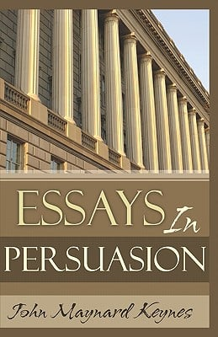](https://images-production.bookshop.org/spree/images/attachments/3698758/original/9781441492265.jpg?1588634320)

Description

Essays In Persuasion written by legendary author John Maynard Keynes is widely considered to be one of the top 100 greatest books of all time. This great classic will surely attract a whole new generation of readers. For many, Essays In Persuasion is required reading for various courses and curriculums. And for others who simply enjoy reading timeless piees of classic literature, this gem by John Maynard Keynes is highly recommended. Published by Classic House Books and beautifully produced, Essays In Persuasion would make an ideal gift and it should be a part of everyone's personal library.

### Product Details

Price

**$9.94**

Publisher

Createspace Independent Publishing Platform

Publish Date

March 03, 2009

Pages

208

Dimensions

5.5 X 0.44 X 8.5 inches | 0.54 pounds

Language

English

Type

Paperback

About the Author

John Maynard Keynes (1883-1946) was one of the greatest economic theorists of the twentieth century. He was chairman of the liberal journal of opinion The Nation and economics advisor for more than thirty years to British governments. He wrote several books, including his masterpiece, The General Theory of Employment, Essays in Persuasion, Interest and Money, the two-volume Treatise on Money, and A Tract on Monetary Reform.

Take on the Street: How to Fight for Your Financial Future

[Arthur Levitt](https://bookshop.org/contributors/arthur-levitt) (Author)

[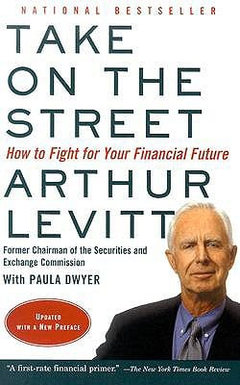](https://images-production.bookshop.org/spree/images/attachments/6244305/original/9780375714023.jpg?1588663568)

Description

In Take on the Street, Arthur Levitt--Chairman of the Securities and Exchange Commission for eight years under President Clinton--provides the best kind of insider information: the kind that can help honest, small investors protect themselves from the deliberately confusing ways of Wall Street.

At a time when investor confidence in Wall Street and corporate America is at an historic low, when many are seriously questioning whether or not they should continue to invest, Levitt offers the benefits of his own experience, both on Wall Street and as its chief regulator. His straight talk about the ways of stockbrokers (they are salesmen, plain and simple), corporate financial statements (the truth is often hidden), mutual fund managers (remember who they really work for), and other aspects of the business will help to arm everyone with the tools they need to protect--and enhance--their financial future.

### Product Details

Price

**$16.00**

Publisher

Vintage

Publish Date

November 11, 2003

Pages

364

Dimensions

5.24 X 0.81 X 8.06 inches | 0.6 pounds

Language

English

Type

Paperback

About the Author

First appointed in 1993, Arthur Levitt was the longest-serving SEC chairman. He was also chairman of the New York City Economic Development Corporation and the American Stock Exchange. He lives in Connecticut.